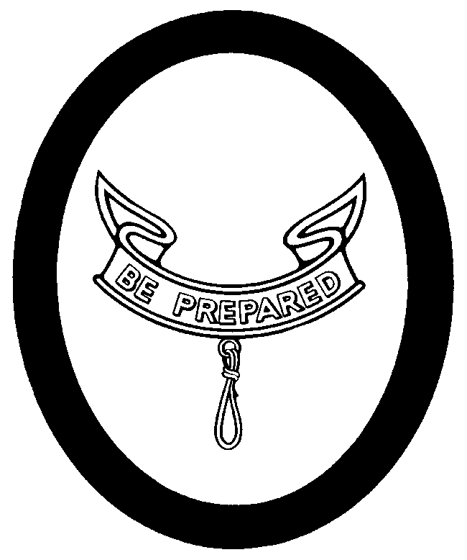
Second Class Personal Growth Agreement Conference

Name: _________________________________Date________ Age: ______ School Grade: ________
I have been in the Scouts for ________ months, including _______ months as a Tenderfoot Scout.
I passed the Progress Revue Board on ____ / ____ / _______

SCOUT SPIRIT:
I have continued to live up to the Scout Spirit by ______________________________________________________
____________________________________________________________________________________________

ADVANCEMENT:
What was the hardest requirement for this rank? _____________________________________________________
From the swimming requirement I learned ___________________________________________________________
From cooking, I learned _________________________________________________________________________
From First Aid, I learned _________________________________________________________________________
What kind of wild animals did you find? _____________________________________________________________
What did you enjoy working on? ___________________________________________________________________
Was it hard to earn your Second Class? ____________________________________________________________

CAMPING:
Since becoming a Tenderfoot Scout, I have participated in the following Camping trips:
_____________________________________________________________________________________________
I liked the ________________________ trip the most because ___________________________________________
The most important things that I have learned from these camp-outs are ____________________________________
_____________________________________________________________________________________________

SERVICE:
I have participated in the following Service Projects since becoming a Tenderfoot Scout:
______________________________________________________________________________________________
I ( ) did, ( ) did not like it because ____________________________________________________________________

PATROL:
My job in the Patrol is ___________________________ To do it, I have to ___________________________________
My Patrol Leader ( ) does, ( ) doesn’t help me. Our Patrol ( ) does, ( ) doesn’t pull together. We
( ) are, ( ) aren’t getting better.

TROOP:
The things that I like most about the Troop are _________________________________________________________
I ( ) do, ( ) don’t like going to Troop meetings. They are __________________________________________________

SCOUT SPIRIT:
I will continue to show my Scout Spirit by _____________________________________________________________

Second Class Personal Growth Agreement Conference Continued

Name_________________________

ADVANCEMENT
What orienteering requirements are needed for First Class? ______________________________________________
______________________________________________________________________________________________
What cooking requirements are needed? _____________________________________________________________
What are the First Aid requirements? ________________________________________________________________
I will try to earn my First Class Progress Award by ______________________________

CAMPING:
I will try to become a more proficient camper by ________________________________________________________
______________________________________________________________________________________________
I will try to take part in ___________________ camping trips before reaching First Class.

SERVICE:
I am trying to learn how to be of service and help to other people. I will try to do it by: ___________________________
______________________________________________________________________________________________

PATROL:
I intend to help my Patrol to become better by _______________________________________________________
Now that I am passing my second stage of Scouting by applying for Second Class, I would like to begin working to become ( ) an Assistant Patrol Leader, ( ) a Den Chief, ( ) Troop Librarian, ( ) Troop Historian, ( ) Member of Troop
Color Guard, or ( ) ______________________________
I think the Patrol can improve by ___________________________________________________________________

TROOP:
I would like to suggest that the Troop do more ________________________________________________________
I think the Troop could do less ____________________________________________________________________
I would like to help the Troop improve by ____________________________________________________________
I ( ) do, ( ) don’t have a friend that I would like to invite to visit the Troop.
If I do have a friend that I would like to invite to visit, I would tell him ________________________________________
_____________________________________________________________________________________________

Respectfully submitted

___________________________________

( ) Accepted
( ) Not Accepted ___________________________________ Scoutmaster Dated: ______ / ____ / ______

Recommendations:

Second Class Rank Requirements for

Scout_____________________ Date __________
Date/Initials | # | Requirements
 | 1a | Demonstrate how a compass works and how to orient a map. Explain what map symbols mean.
 | 1b | Using a compass and a map together, take a five-mile hike (or 10 miles by bike) approved by your adult leader and your parent or guardian.*
 | 2 | Discuss the principles of Leave No Trace.
 | 3a | Since joining, have participated in five separate troop/patrol activities (other than troop/patrol meetings), two of which included camping overnight.
 | 3b | On one of these camp outs, select your patrol site and sleep in a tent that you pitched. Explain what factors you should consider when choosing a patrol site and where to pitch a tent.
 | 3c | Demonstrate proper care, sharpening, and use of the knife, saw, and ax, and describe when they should be used.
 | 3d | Use the tools listed in requirement 3c to prepare tinder, kindling, and fuel for a cooking fire.
 | 3e | Discuss when it is appropriate to use a cooking fire and a lightweight stove. Discuss the safety procedures for using both.
 | 3f | In an approved place and at an approved time, demonstrate how to build a fire and set up a lightweight stove. Note: Lighting the fire is not required.
 | 3g | On one camp out, plan and cook one hot breakfast or lunch, selecting foods from the food guide pyramid. Explain the importance of good nutrition. Tell how to transport, store, and prepare the foods you selected.
 | 4 | Participate in a flag ceremony for your school, religious institution, chartered organization, community, or troop activity. Explain to your leader what respect is due the flag of the US.
 | 5 | Participate in an approved (minimum of one hour) service project.
 | 6 | Identify or show evidence of at least 10 kinds of wild animals (birds, mammals, reptiles, fish, mollusks) found in your community.
 | 7a | Show what to do for “hurry” cases of stopped breathing, serious bleeding, and ingested poisoning.
 | 7b | Prepare a personal first-aid kit to take with you on a hike.

Second Class Rank Requirements continued for

Scout_____________________ Date __________

Date/Initials | # | Requirements
 | 7c | Demonstrate first aid for the following:  · Object in the eye  · Bite of a suspected rabid animal  · Puncture wounds from a splinter, nail, and fishhook  · Serious burns (partial thickness, or second-degree)  · Heat exhaustion  · Shock  · Heatstroke, dehydration, hypothermia, and hyperventilation
 | 8a | Tell what precautions must be taken for a safe swim.
 | 8b | Demonstrate your ability to jump feet first into water over your head in depth, level off and swim 25 feet on the surface, stop, turn sharply, resume swimming, then return to your starting place.
 | 8c | Demonstrate water rescue methods by reaching with your arm or leg, by reaching with a suitable object, and by throwing lines and objects. Explain why swimming rescues should not be attempted when a reaching or throwing rescue is possible, and explain why and how  a rescue swimmer should avoid contact with the victim.
 | 9a | Participate in a school, community, or troop program on the dangers of using drugs, alcohol, and tobacco and other practices that could be harmful to your health. Discuss your participation in the program with your family, and explain the dangers of substance addictions.
 | 9b | Explain the three R's of personal safety and protection.
 | 10 | Earn an amount of money agreed upon by you and your parent, then save at least 50 percent of that money.
 | 11 | Demonstrate Scout spirit by living the Scout Oath (Promise) and Scout Law in your everyday life. Discuss four specific examples (different from those used for Tenderfoot requirement 13) of how you have lived the points of the Scout Law in your daily life.
 | 12 | Participate in a Scoutmaster conference.
 | 13 | Complete your board of review.

Note: Alternate requirements for the Second Class rank are available for Scouts with physical/mental disabilities
- The requirements for Tenderfoot, Second Class, and First Class ranks may be worked on simultaneously; however, these ranks must be earned in sequence.

